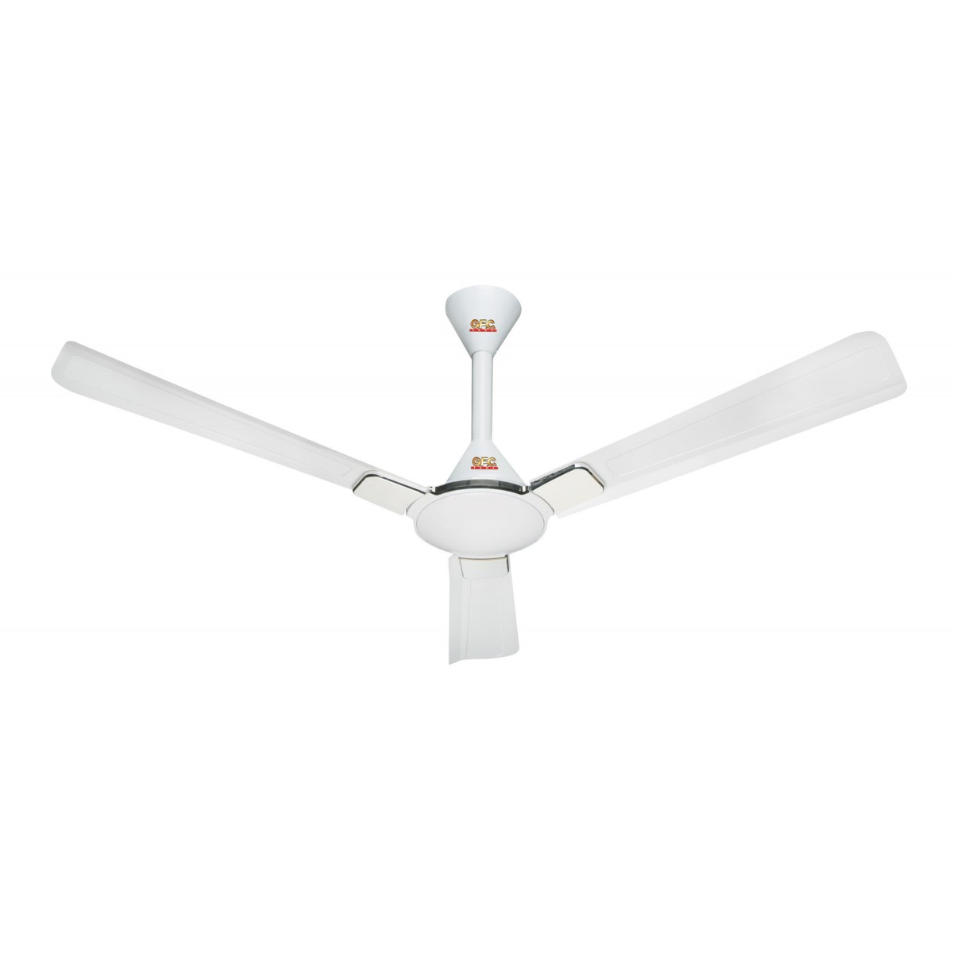

Auto 255ES

* Smart Slim Shape
* 220V Operated
* Big Size Drum
* White Color
* **Rs.41,000**